An Introduction to the Diagrams in Masechet Eruvin
Eli Genauer

For those studying the Talmud in the Daf Yomi cycle, Masechet Eruvin represents a sea change in the “Tzurat HaDaf”( form of the page) . Instead of pages that contain only words, Masechet Eruvin has pages that look like this: ( Eruvin 9b, Rashi)
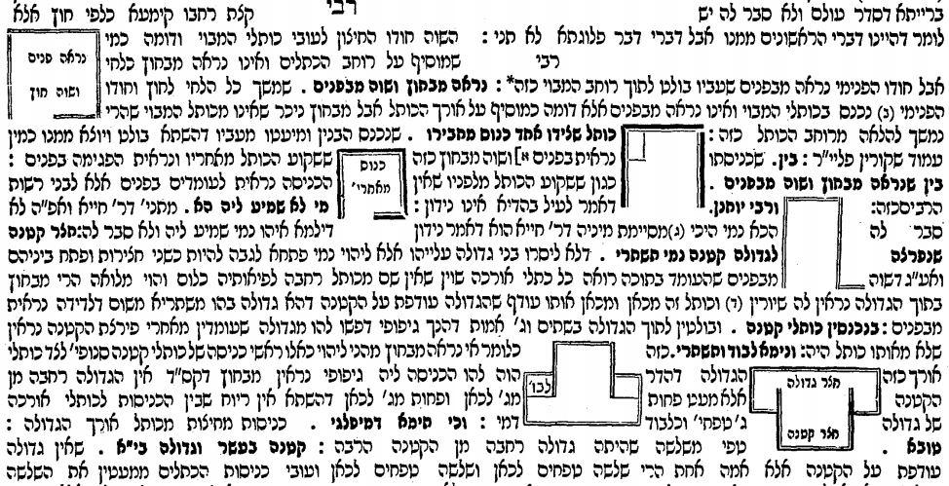
There are 54 such diagrams in Rashi’s commentary to Masechet Eruvin and they represent about half of the total of diagrams found in Rashi’s commentary in the rest of the Talmud. I have been studying these diagrams for the past 10 years and when I speak to people about it, the first thing they want to know is “Did Rashi really draw the diagrams that we see today in the Vilna Shas?” The answer I give them is a resounding “yes, but with some qualifications”. Rashi definitely drew diagrams to illustrate his words. This assertion is reflected in the words of Dr. Ezra Chwat , director of the department of manuscripts at The National Library of Israel “The underlying basis of our work is that pictures are an organic part of the commentary, and it possible that Rashi even allowed himself to limit his explanatory words when a picture was available to the reader. This is in the sense of “a picture is worth a thousand words”. The picture is an integral part of the written book, no less important than the words.”
We do not have an autograph Ktav Yad (meaning a manuscript written by Rashi himself) of his commentary to Talmud Bavli , but we have many hand written manuscripts of his commentary which were created not too long after Rashi lived. Many of them contain the types of diagrams that we see today. They are not always exactly the same as in the Vilna Shas, but they are oftentimes very close. The best way to illustrate this is well….with an illustration from the very first page in Eruvin (2a)

The first Mishnah in Eruvin speaks about the issue of carrying in an alleyway (Mavoy) which is closed on three sides but open on the fourth side to the public domain ( Reshut Harabim) . (From Peirush Chai on hebrewbooks.org) https://hebrewbooks.org/pdfpager.aspx?req=47535&st=&pgnum=7
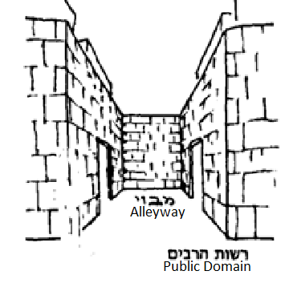
In the times of the Mishnah, houses would open up to courtyards which then opened up to an alley which led to the street. Since the alleyway is enclosed on three sides and is a dead end on one side, from a Torah level perspective it is considered a Reshut HaYachid (private domain) and carrying would be permitted within it. But our Sages were concerned that since on the fourth side it led out to the public domain where carrying is prohibited, people would be confused and extend their carrying activities from the alleyway into the street. They therefore prohibited carrying in the alleyway if the opening on the fourth side was wider than ten Amot. A simple solution to that to allow carrying in the alleyway would be to construct a real doorway, a two-sided doorframe and a lintel on the top, on the open fourth side. But our Sages permitted an easier solution to the problem which was to construct a Tzurat HaPesach (literally, a “form of a doorway”) on the open fourth side. It turns out that the Halachic concept of a Tzurat HaPesach is used in the construction of modern day Eruvin all across the Jewish world. The key then is to understand what is a Tzurat HaPesach. In typical concise fashion, Rashi explains that a “Tzurat HaPesach” is “Lechi Mikan, V’Lechi Mikan, V’Koreh al Gabaihem”. Rashi then adds the word “Kazeh”, “like this”, and includes the following diagram which is part of the Vilna Shas
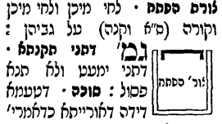
The diagram is an integral part of Rashi’s explanation. Rashi could have written that to construct a Tzurat HaPesach you need to install a board on one side of the opening, another board on the opposite side of the opening and then connect those two boards with a board on top of them. But instead, Rashi just wrote, “a board here, a board there, and a board on top”, and illustrated it with a picture, At the top of the diagram there is a horizontal board attached to two perpendicular boards on the side.
What illustration do we think Rashi draw? We don’t know exactly because as stated, we do not have an autograph Ktav Yad of Rashi. However, we do have handwritten manuscripts from not too long after Rashi lived that reflected the original writing of Rashi. It is from manuscripts such as these that we derive the proper wording of Rashi, and we can also use them to get an idea of the pictures that Rashi drew. In this case I found five manuscripts written from the 1200’s to the 1400’s which all have the same drawing. The drawing shows an opening on which two vertical posts and one horizontal post are installed. It is always extremely exciting for me to see these hand drawn diagrams and I would like to share three of them with you.
This is a manuscript known as Munich 216 which was copied over approximately within 150 years of the time of Rashi
This is a manuscript of an unknown date known as Vatican 127 which features the diagram in a very clear fashion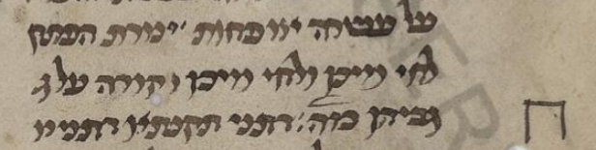

This is a manuscript identified as National Library of Russia EVR II A 266/1 of which the date is also unknown where the diagram is very clear
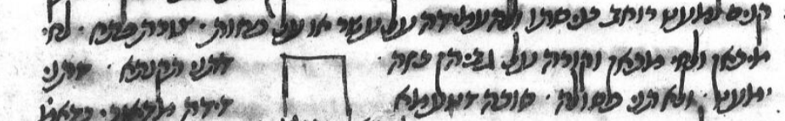
We also have the first printed Eruvin published by Gershom Soncino in Pesaro, Italy in 1516 which clearly shows the diagram. Since the source of this first printed edition had to be a manuscript, we know that it contained such a diagram.
http://www.internetculturale.it/jmms/iccuviewer/iccu.jsp?id=oai%3Awww.internetculturale.sbn.it%2FTeca%3A20%3ANT0000%3APARE078466&mode=all&teca=MagTeca+-+ICCU&fulltext=1
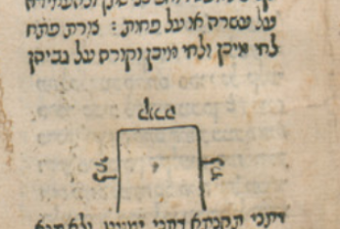
The diagram was improved a bit by the editors of the Talmud printed in Amsterdam in 1716 and has remained in that form until today
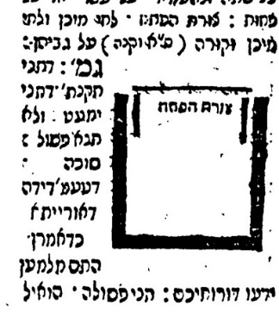
Amsterdam 1716 Vilna Shas
In summary, we see handwritten manuscripts containing Rashi’s commentary to the Talmud which included not only the text that Rashi wrote, but also attempted to recreate the diagrams that Rashi drew to illustrate his words. They are a helpful addition to us in trying to form a picture in our minds of the cases of which the Gemara speaks.

Giluy B’Milta Blog, January 15th ,2017
If the opening is less than ten Amot, it is considered a doorway on its own, but if it is wider than ten Amot, it is considered a rupture ( Pirtzah) and some sort of doorway needs to be constructed there to close it off.
In it’s introduction to Eruvin, Artscroll ( Mesorah Publications, Brooklyn, NY 1990 page xxvii) notes “ This device is widely used nowadays to convert a Karmelis( semipublic domain) to a Reshus HaYachid ( and is colloquially known as an Eruv)”
The National Library of Israel listing for this manuscript states that the copyist was Yehuda ben Binyamin of Lunel and estimates that it was written in the 13th century. https://web.nli.org.il/sites/NLIS/en/ManuScript/Pages/Item.aspx?ItemID=PNX_MANUSCRIPTS990001278630205171
https://digi.vatlib.it/view/MSS_Vat.ebr.127
https://web.nli.org.il/sites/NLIS/en/ManuScript/Pages/Item.aspx?ItemID=PNX_MANUSCRIPTS990001436150205171

