כריתות ה': צורת ״כִּי יְוָנִי״
Eli Genauer
גמרא כריתות ה':
תָּנוּ רַבָּנַן מוֹשְׁחִין אֶת הַמְּלָכִים כְּמִין נֵזֶר וְאֶת הַכֹּהֲנִים כְּמִין כִּי אָמַר רַב מְנַשְּׁיָה כְּמִין כִּי יְוָנִי
The Sages taught: One anoints the kings by placing the oil around the head similar to a crown, and one anoints the High Priests by placing the oil upon the head similar to a “כִּי”. Rav Menashya says: It is similar to the “כִּי יְוָנִי”.
Rashi first tells us that a “כִּי יְוָנִי” is a Greek letter which looks like this . He then explains that oil is placed on the head of the Kohen Gadol and afterwards between his eyelashes and is combined on the forehead.
In the Vilna Shas the “כִּי יְוָנִי” is drawn as an “X”
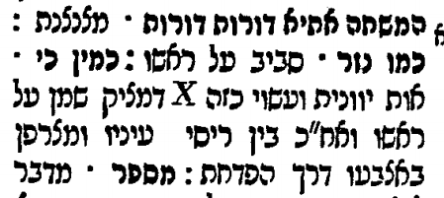
The source for the use of an “X” to represent a “כִּי יְוָנִי” sems to be a commentary on ספר הערוך called מוסף הערוך published in Amsterdam 1655 and authored by Binyamin Mousafia (1606-1675). He says that the “כִּי יְוָנִי” is the 22nd letter of the Greek alphabet and its form is two diagonal lines that cross in the middle. He is clearly referring to the Greek letter “Chi” which is drawn as an “X”.
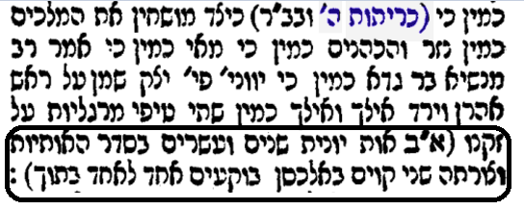
It has been argued that this representation of a “כִּי יְוָנִי” as an “X” does not match the words of the ספר הערוך who writes that “כִּי יְוָנִי” describes what it looks like when oil is placed on Aharon’s head and then drips down like two pearls on to his beard.
The Oz Vehadar Murchav edition of the Talmud (Jerusalem 2016) deviates from the “Tzurat HaDaf” of the Vilna Shas and leaves a blank space with the footnote notation [כ״ח where the “X” appears in the Vilna Shas.
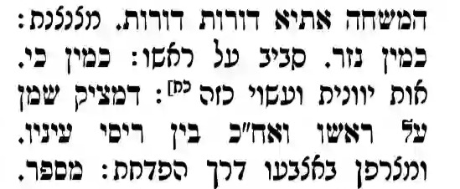
This footnote informs us that there are different representations of the “כִּי יְוָנִי” in Rashi in other printed editions and that in Rashi, commenting on the same ברייתא in Horayos 12a, it is represented by the Hebrew letter “ח”
I did find a wide representation of the “כִּי יְוָנִי”in early printed editions
The first printed edition of כריתות מסכת was by Daniel Bomberg in 1522. It had the word “כזה” and left a space. Clearly it was copied from a manuscript which had the word “כזה” and which may have had a picture.
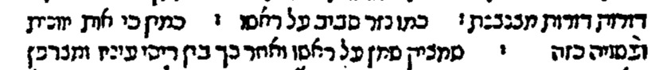
The Basel edition of 1580 includes very few diagrams, but here it represents the “כִּי יְוָנִי” with what looks like the Hebrew letter “ג” or the Greek letter Lambda
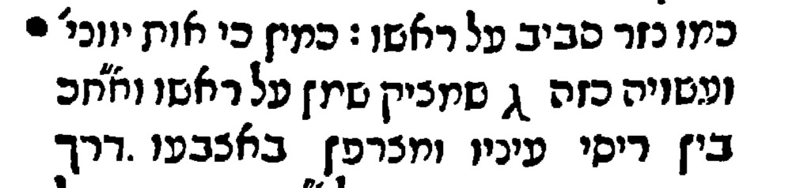

ג

It was also unusual for Amsterdam 1647 to have a diagram, but here it depicts it as )(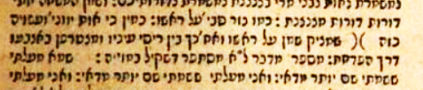
A colleague pointed out that the Soncino Pesaro edition of Rosh Hashana (1516) has a similar representation for the סימניות הפוכות placed in front of 6 Pesukim in Tehillim (107:23-28)
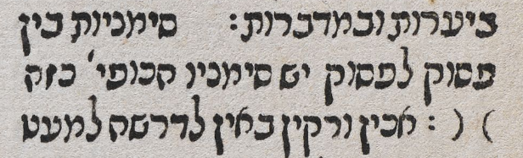
The Frankfurt am Main edition of 1720 contains a picture of an upside-down U, as does Amsterdam 1764, Sulzbach 1762, and Vienna 1797. It does seem to resemble a “ח”
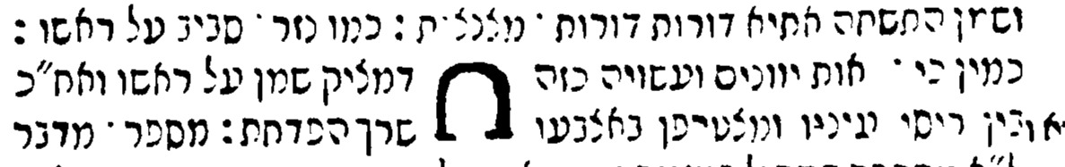
Amsterdam 1764
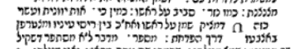
Sulzbach 1762
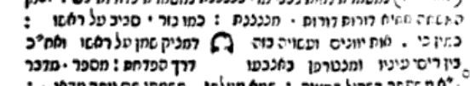
Vienna 1797
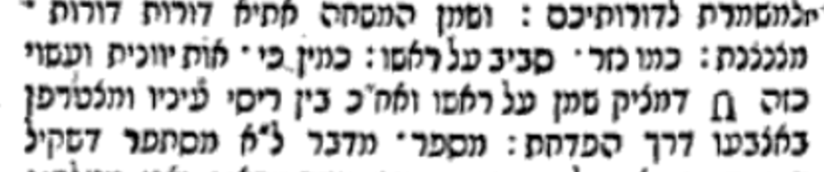

There is one manuscript of Rashi on כריתות although it was copied over quite late. The “כִּי יְוָנִי” looks completely different in this manuscript.
The National Library of Russia, St. Petersburg, Russia Ms. EVR IV 25
Date: 1563
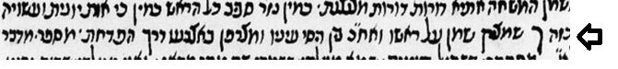
It turns out that there are quite a few different representations of the “כִּי יְוָנִי”in the one manuscript and the various printed editions
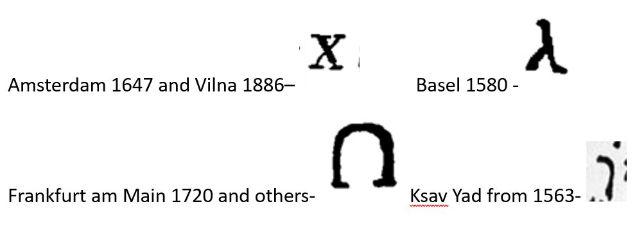
We find others commenting on the diversity of forms proposed as to the shape of the “כִּי יְוָנִי”. Tosfos in Menachos 75a notes that Rashi drew something like the letter “ט” to represent the “כִּי יְוָנִי” and in Chumash he drew a “ג”. Tosfos notes that others drew a Nun or something like a Chuf
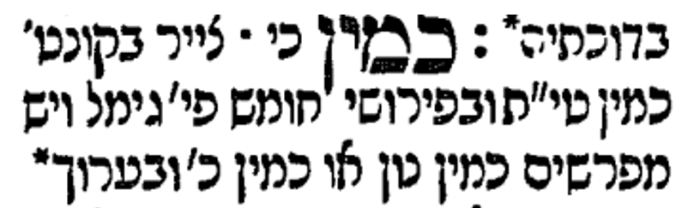
One of the more intriguing representations of the “כִּי יְוָנִי” is found in the oldest dated manuscript of Gemara that we have. As you can see, it was found in the Cairo Genizah and is dated to the year 1123. Dr. Ezra Chwat describes the manuscript as follows:
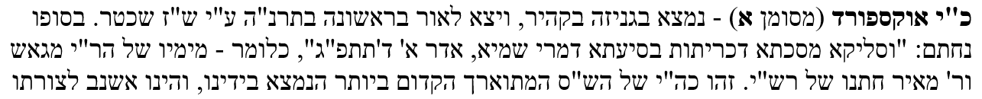

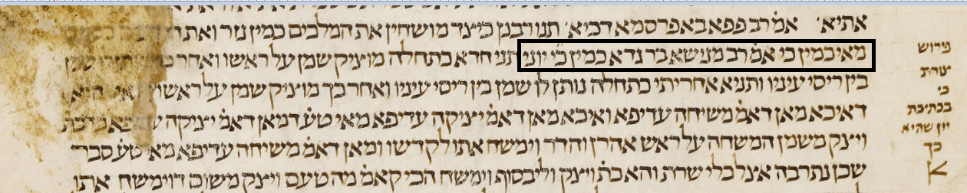
Note the writing on the side which says “פרוש צורת כי בכתיבת יון שהיא כך” and after which appears to us like the English letter “K”. I asked Dr. Chwat if that notation was also from 1123 and he said it was possible, but it was also possible that it was added later.
When the Gemara said that the anointing of the Kohen Gadol was done in the shape of the Greek letter “כִּי”, it was referring to a shape with which everyone was familiar. We know that Rashi did draw a representation of the “כִּי יְוָנִי” because Tosfos attest to it. Unfortunately, we do not have a כתב יד of Rashi nor any manuscripts which were written close to the time of Rashi. Because there are so many representations of the “כִּי יְוָנִי”, we are left quite in the dark.

Either because of technical reasons or cost, the Bomberg Shas did not include diagrams, save for two exceptions. Instead, it left an empty space where the diagram appeared in the manuscript.
Note that the Soncino text incorrectly records Rashi as saying theסימניות are הכופין instead of הפוכין This is the way these Pesukim appear in the נוסח המקובל of Mikraos Gedolot of Daniel Bomberg 1524-26 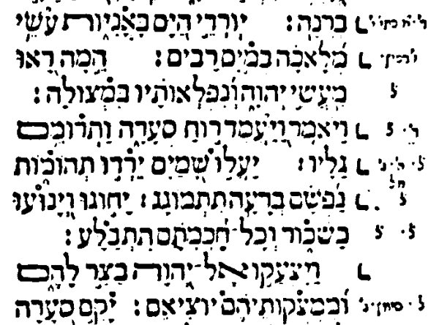
Rabbeinu Gershom writes that it was like the letter Ches, probably most similar to the upside down “U”. כמין נזר. משחו במצחו מאוזן לאוזן וערפו אחוריו כלומר סביב סביב כמין כי יווני ח כך מן המצח על גבי הראש עד העורף ומפרש כמין כי:
Today we might say that something was in the shape of the universal “Yield” sign and everyone would know that it was in a triangular shape with two corners on the top and one on the bottom. 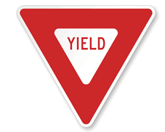 Years from now, people might not be familiar with such signs and the meaning would be unclear

